A spatial analysis of the robustness of the “private kill” abattoir network in the UK: a proof of concept study
Jeremy R. Franks, Jessica Hepburn, Rachel Peden
Long-term trend in the closure of abattoir businesses has reduced “private kill” provision across the UK, leading to longer and more complex livestock journeys - jeopardising animal welfare, and threatening the viability of the locally-finished and -slaughtered red meat supply chain. This “proof of concept” study uses farmer and abattoir survey data, GIS software and Monte Carlo simulations to estimate the impacts of possible further closures of private kill abattoirs on the robustness of the private kill network. In August 2020, we estimate 18% of the UK was further than 45kms from a private kill abattoir, while 21% was serviced by one, 14% by two and 47% by three or more abattoirs. We estimate the robustness of the private kill network by calculating the size of these areas in turn should 9% or 18% of the existing private kill abattoirs stop operating. In both scenarios the area further than 45km from a private kill service, and with one and two providers increased, while the area with three or more providers decreased. The discussion considers additional information needed to allow this methodology a become a useful tool for supporting the private kill network by providing support to strategically located abattoir businesses within the overarching network of private kill businesses.

(Key words: private kill, survey, abattoirs, GIS, Monte Carlo, financial stress)

1 Introduction

Two key UK government policy objectives are to reduce unnecessary movements of livestock and to support rural economies (Defra, 2021). The ability to meet these objectives makes the closure of abattoirs across the UK a matter of public concern (Efra, 2021, APGAW, 2020) because it can lead to longer and more complex livestock journeys – with its associated risks to animal welfare, and threaten the viability of the farmer’s private kill retail (PKR) enterprises, and therefore the rural economy through the readjustment of the size and distribution of businesses in the locally-finished and -slaughtered red meat supply chain.

Private kill (PK) services require abattoirs to return to farmers the carcase (or butchered joints) from the same livestock the farmers had sent for slaughter. To honour this guarantee abattoirs need to establish robust traceability protocols throughout their processing line, from taking delivery of livestock, through slaughtering, butchering and processing, and storage of the carcase. As this imposes additional costs and, critically, restricts daily and annual throughput, PK has become a specialist service predominately offered by smaller abattoirs (APGAW, 2020, Franks and Peden, 2021, Efra, 2021, Kennard and Young, 2018).

However, between 2001 and 2017, the number of smaller abattoirs in the UK fell from 260 to 170 (APGAW, 2020: p 11). More recent research undertaken for this study shows that a further 13 of the 160 PK abattoirs working in January 2019 closed in the 20 months to August 2020 (some 9% of the underlying population). Our survey of PKR farmers completed at the same time showed that 41% of respondents were without a viable alternative abattoir if the one they were currently using was to close (Franks and Peden, 2021). Further closures therefore threaten not only these farm businesses but also the viability of all businesses in the local red meat supply chain which depend on this service (APGAW, 2020, Efra, 2021).

These concerns have led to calls for abattoirs to be treated as “a national strategic asset” (Efra, 2021: p 4). But although abattoirs are included in the list of “ancillary” businesses eligible for support in the Agriculture Bill, no attempt has so far been made to estimate the impacts of further closures on the robustness of the PK network. Such a study would help to advise how support could be best targeted to safeguard animal welfare and businesses in the local red meat supply chains. This study is a first step to address this deficiency. It uses farmer and abattoir survey data, the Geographic Information System (GIS) software ArcGIS Pro, and Monte Carlo simulations to estimate the change in the geographical area serviced by PK abattoirs resulting from the further closure of abattoirs.

2 Analytical framework and study methods
This analysis assumes that the smaller the area without PK services and the larger the areas with multiple abattoir coverage the more robust the PK network is. In principle, therefore, the resilience of the PK network can be tested by removing abattoirs from the underlying population, calculating the resulting geographic coverage and comparing these results against the baseline (i.e. current) coverage. Ideally, the abattoirs removed from the network would be those that are most likely to close. However, as this information is not available this is a proof of concept study which uses Monte Carlo simulations to randomly remove PK abattoirs from the network of PK abattoirs trading in August 2020. The resulting scenarios quantify the impacts of the closures to demonstrate the potential of the methodology.

2.1 Survey of abattoirs providing private kill services
The study collected information from an online survey of farmers who use abattoirs for their PKR businesses, the number of livestock sold through the PKR business each year, and the distance livestock travelled from the farm for PKR slaughter. Forty relevant organisations were approached via email for assistance in promoting the survey. Those which did not respond after 4 weeks were contacted again. A total of 21 organisations agreed to share the survey URL via their newsletters, social media streams and mailing lists. As there is no national database of abattoirs that provide PK services, a telephone survey of abattoirs was undertaken to identify the existing service provision. All 220 abattoirs currently trading were contacted, using contact details then publicly available from the Agricultural and Horticultural Development Board (AHDB) supported by internet searches. This identified 147 abattoirs offering PK services across the UK in August 2020. Additional description of the survey methodologies can be found in Franks and Peden (2021).

2.2 GIS methodology
Monte Carlo simulations have been used alongside spatial analysis for several years. The flexibility and volume of tools available within ArcGIS means that methods can be widely applied allowing results to be visualised to gain additional meaning from data (Brown et al., 2009, Park et al., 2013, Toma-Danila, 2018).
Postal code data points generated by the abattoir survey were used in ArcGIS software to estimate the area of the UK further than 45kms away from a PK abattoir, and the areas covered by one, two and three or more PK abattoirs in August 2020. The stages of spatial analysis are demonstrated in Figure 1. Firstly, the buffer tool was applied to the abattoir dataset (Jensen and Jensen, 2013). The distance used for the buffer area was derived from the farmer survey and a review of the literature (see below). The output produces a series of circles denoting the spatial proximity of abattoirs to each other. The data were clipped so that areas of the buffers which overlayed the coastal outline of the UK were removed. To calculate the number of abattoirs servicing any place across the UK, buffers overlaying each other were counted to produce a dataset in which every place in the UK had a value of how many abattoirs serviced it.

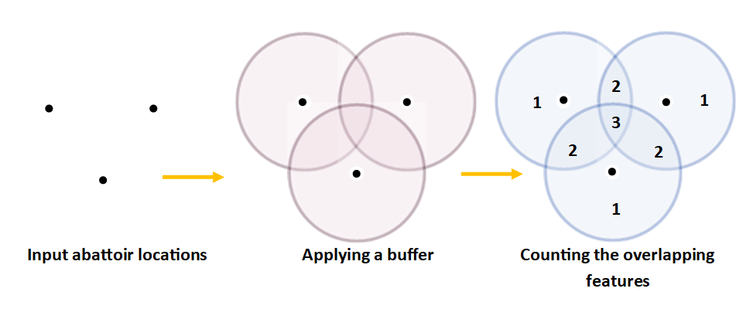
Figure 1. Stages of spatial analysis used by GIS
This allowed each area of land to be classified as being serviced by no abattoir, by one abattoir, by two abattoirs, and by three or more abattoirs. To estimate the percentage of the UK covered by each of these four categories the overlapping features were “dissolved” to produce a single dataset (rather than a series of buffers).
This process was repeated to produce estimates of the geographical area covered calculated for the reduced population of abattoirs following the random removal of individual businesses identified by the Monte Carlo simulations.

3 Survey findings: the baseline distribution of abattoirs (August 2020)
The choice of a straight-line, “as the crow flies”, 45km as the radius for the buffer zones drawn around each of the 147 PK abattoirs (shown in Figure 2) was based on results from the farmer survey and a review of the literature. Figure 3 shows that 45kms is the distance 50% of livestock travelled from farm to abattoir for PKR slaughter (Franks and Peden, 2021) and Figure 4 shows that 60% of farmers farmed within this distance of the abattoir. As the buffer is created as a straight line radius, and as Figure 3 estimates the travel distance from farm to abattoir, the non-linear transport network means a 45km buffer will result in longer than 45km journeys, and therefore encompass more than 50% of livestock and 60% of farmers. Secondly, it draws on the findings of a literature review into consumers perceptions of what is meant by “local” food. Several studies reported consumers defining “local food” as food produced within 30 miles (i.e. approximately 45 kms) of the point of sale (Pearson et al., 2011, ICF Consulting Services, 2016, Campaign to Protect Rural England, 2012).

Figure 2. The location of the abattoirs offering private kill services in the UK in August 2020 with 45km buffer zones.
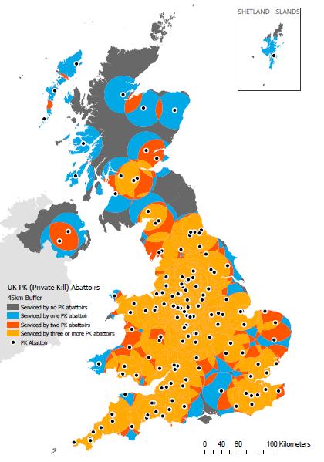

Figure 3. The cumulative distribution of the percentage of livestock and the distance travelled from farm to abattoir for private kill slaughter.

Figure 4. The cumulative distribution of the percentage of farmer and the distance from the farm to abattoir for private kill slaughter.

Table 1 presents the geographic coverage of PK services across the UK based on 45km buffer zones. It shows that in August 2020, 18.22% of the UK was further than 45kms from an abattoir offering PK services, and 20.88% of the UK had only one abattoir providing this service within this distance of the farm.

Table 1. The area (km²) and percentage of the UK without private kill abattoir provision, covered by one, two and three or more abattoirs (based on 45km buffers).
Number of private kill abattoirs | Area covered (km²) | % of UK covered by the number of abattoirs in column 1
0 | 44,510 | 18.22%
1 | 50,989 | 20.88%
2 | 33,809 | 13.84%
3 or more | 114,917 | 47.05%
Total | 244,226 | 100%

4 An estimate of the robustness of the private kill network using Monte Carlo simulations
This study uses Monte Carlo simulations are used to randomly remove abattoirs from the underlying population to allow the geographical coverage of PK services provided by the remaining abattoirs to be calculated and compared again the baseline coverage in August 2020 (shown in Table 1). The number of abattoirs removed from the August 2020 population was derived from the rate of closure of PK abattoirs in the 20 months to August 2020, when thirteen abattoirs (some 9% of the underlying population) ceased trading. Therefore, the first simulation randomly selected and removed (i.e. assumed closed for trading) 9% of the 147 abattoirs offering PK services, simulating the possible network in 20 months assuming a constant rate of attrition. Seven simulation runs were completed, creating seven data sets, each of 134 abattoirs. Table 2 presents the results averaged across the seven simulations: 20.6% of the UK was further than 45km from an abattoir, 21.2% was covered by one, 15.4% by two, and 42.8% by three or more abattoirs. Table 2 also show the areas covered by the simulation runs that resulted in the smallest area (18.6%) and the largest area (23.1%) further than 45km from an abattoir. The maps for the simulation runs with the smallest and largest areas more than 45kms from a PK abattoir are shown in Figures 5 and 6 respectively.
To simulate the possible network of PK provision after 40 months, a second set of seven simulations was run randomly removing 18% of the 147 abattoirs in the August 2020 population, creating seven further datasets, each with 121 abattoirs. Table 2 show the average across the seven simulations: 24.2% of the UK was further than 45km from a PK abattoir, 21% was covered by one, 15.5% by two, and 39.3% by three or more abattoirs. The maps for the simulation runs resulting in the smallest (i.e. the most optimistic outcome) and largest (i.e. the least optimistic outcome) areas further than 45kms from a PK abattoir are shown in Figures 7 and 8 respectively.
Table 3 compares the coverage shown in Table 2 with the baseline coverage for August 2020 shown in Table 1. The area further than 45km from a PK abattoir increased in both simulations, by 2.3% (from 18.2% to 20.6%) and by 6% (from 18.2% to 24.2%). Farmers in areas no longer within 45km of an abattoir will have longer livestock journeys, adding to their transport costs and making it more economical to use commercial transports (rather than farm transport) to move livestock, which is likely to result in more complex journeys from farm to abattoir, more difficult loading and unloading of livestock (due to the steeper ramps needed for commercial transporters) and mixing of livestock.
There is also an expansion in the geographical areas covered by one single abattoir, by 0.3% and 0.1% for the 9% and 18% runs respectively, and by two abattoirs (1.5% and 1.6% respectively), thus expanding the areas with reduced choice. However, the increase is slight, as any expansion in area resulting from the removal of an abattoir is partially compensated for by removal abattoirs from areas covered by 3 or more abattoirs. It is this area which has been most reduced, by 4.2% and 7.8% in the 9% and 18% runs respectively. Although the areas with three or more abattoirs remain substantial (42.8% and 39.3% respectively), taken together, these results clearly show the potential for this methodology to estimate the degree of “redundancy” found in PK provision across the UK.
Therefore, the results confirm that a combination of surveys and the elimination of PK abattoirs used in this study can assess the robustness of the network of PK abattoirs. However, to be more useful for the purpose of developing the policies and instruments needed to support the PK network, abattoir- and farmer-specific information is needed to identify those abattoirs that are most likely to close (thus removing the need to identify closures by random selection) and the change in distance and complexity of livestock journeys from farm to abattoir.
Table 2. The average areas averaged across all seven Monte Carlo simulations, and the simulations that show the smallest and largest areas further than 45kms from a private kill service.
% of abattoirs randomly removed (number) | Number of abattoirs within 45km | Km² coverage |  |  | % coverage
 |  | Average across all seven data sets | Smallest area without coverage | Largest area without coverage | Average across all seven datasets | Smallest area without coverage | Largest area without coverage
9% (13) | 0 | 50,239 | 45,402 | 56,309 | 20.6% | 18.6% | 23.1%
 | 1 | 51,808 | 48,235 | 57,591 | 21.2% | 19.8% | 23.6%
 | 2 | 37,571 | 34,869 | 40,377 | 15.4% | 14.3% | 16.5%
 | 3 or more | 104,609 | 101,312 | 109,550 | 42.8% | 41.5% | 44.9%
 | Total | 244,226 |  |  | 100%
18% (26) | 0 | 59,151 | 49,797 | 78,991 | 24.2% | 20.4% | 32.3%
 | 1 | 51,337 | 37,686 | 61,499 | 21.0% | 15.4% | 25.2%
 | 2 | 37,832 | 28,934 | 44,790 | 15.5% | 11.8% | 18.3%
 | 3 or more | 95,9076 | 90,034 | 99,314 | 39.3% | 36.9% | 40.7%
 | Total | 244,226 |  |  | 100%

Table 3. Change in the geographical area covered by abattoirs following the closure of 9% and 18% of population of private kill abattoirs trading in August 2020.
 | % of UK covered
 | Number of abattoirs within 45km
 | 0 | 1 | 2 | 3 or more
Baseline (147) | 18.2 | 20.9 | 13.8 | 47.1
Removal of 9% of abattoirs (134) | 20.6 | 21.2 | 15.4 | 42.8
Removal of 18% of abattoirs (121) | 24.2 | 21.0 | 15.5 | 39.3
 | Absolute change in coverage compared to baseline areas
Closure of 13 abattoirs (134) | 2.3 | 0.3 | 1.5 | -4.2
Closure of 26 abattoirs (121) | 6.0 | 0.1 | 1.6 | -7.8

Figure 5. Map showing the smallest area of the UK without any private kill provision (assuming 9% of the 147 abattoirs offering private kill services in the UK in August 2020 close and livestock travel no more than 45kms.)
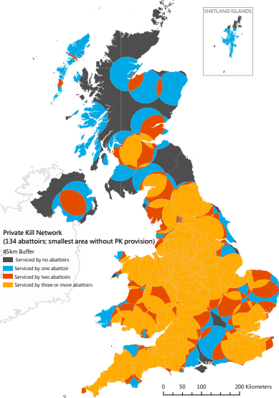

Figure 6. Map showing the largest area of the UK without any private kill provision (assuming 9% of the 147 abattoirs offering private kill services in the UK in August 2020 close and livestock travel no more than 45kms.)
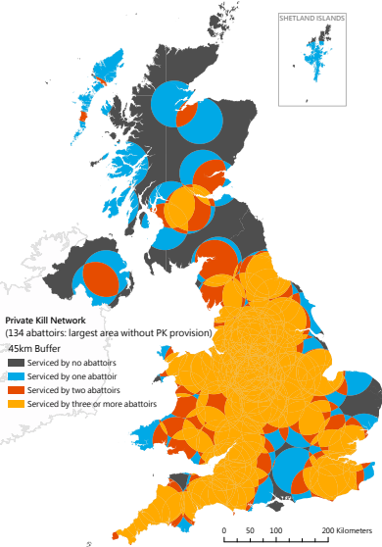

Figure 7. Map showing the smallest area of the UK without any private kill provision (assuming 18% of the 147 abattoirs offering private kill services in the UK in August 2020 close and livestock travel no more than 45kms.)
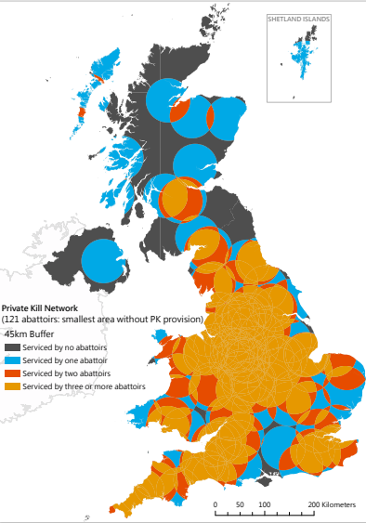

Figure 8. Map showing the largest area of the UK without any private kill provision (assuming 18% of the 147 abattoirs offering private kill services in the UK in August 2020 close and livestock travel no more than 45kms.)
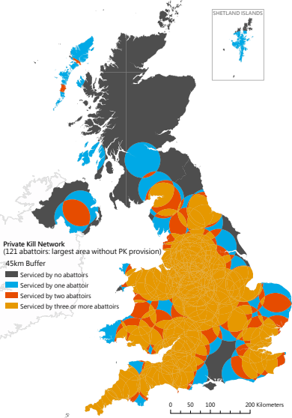

5 Discussion
The variation in geographical coverage confirms the importance of identifying which abattoirs are going to close for assessing the robustness of the resulting network. This will also determine the distance and complexity of livestock journeys, the thereby influences the viability of farmer’s PK retail enterprises, which has consequences for the value of produce sold through the locally finished and slaughtered red-meat supply chain. This section reviews the abattoir and farmer specific information that would be needed to be able to identify which abattoirs are under the most financial stress and therefore most likely to close.

5.1 Abattoir-specific information requirements
Replacing the random removal of abattoirs by abattoirs most likely to cease trading requires detailed information about the short- and long-term viability of abattoirs. A census of trading abattoirs would need to include abattoirs which currently do not offer PK services because these businesses may start to do so. This would require detailed financial information including, for example, trends in and annual cash flows, profitability, throughput, level and types of debt, and net worth. However, experience shows it is unlikely all abattoir would provide such information (Franks and Peden, 2021). Small abattoirs exist in a highly competitive market making such financial information highly confidential. Moreover, many abattoirs currently not providing PK services are unlikely to want to reveal the circumstances under which they would start to offer such services.
Nevertheless, if sufficient owners did provide these data, they could be used, alongside readily available information on, for example, annual abattoir throughput, closeness to other PK abattoirs, the uniqueness of the butchery services offered, and location in relation to areas of livestock production, to approximate and thereby classify the financial status of non-respondents.

5.2 Farmer-specific information requirements
When a PK abattoir ceases trading, its supplying farmers need to assess the suitability of alternative abattoirs for their PKR business needs. The less attractive any alternative abattoir is, the more likely the farmer’s PKR business would close (Franks and Peden, 2021). This would reduce the throughput and thereby jeopardize the viability of local-finished and -slaughtered red meat supply chains. Therefore a survey of PKR farmers would need to identify which (if any) of the abattoirs which remain trading the farmer would use, and to gather details of the resulting choice on the distance (in kms and time) and complexity of the livestock journeys from farm to abattoir.

5.3 The next step
If these more detailed data were available, the used of GIS for visual representation of the data used in this study could be replaced by more accurate estimates of geographic coverage. For example, including transportation networks and associating standard transport speeds for different classes of road in the analysis would allow more accurate estimates of the change in livestock journey time and distance and complexity resulting from abattoir closures. With the appropriate survey data, such an analysis could assess the impacts of adding to the PK network working abattoirs which are not currently offering PK services.
More accurate information would also be of help in developing viable business models for mobile abattoir services, which may be more efficient and economical ways to replace lost PK services in some areas of the UK (Babb and Kennedy, 2012, Fisher et al., 2004, Lambooij et al., 2011, Wood, 2019, Menzies et al., 2020).

6 Conclusions
The further closure of PK abattoirs will result in longer and more complex livestock journeys from farm to abattoir. The extent to which this will be detrimental to animal welfare and undermine farmers’ PKR enterprises, which in turn would threaten businesses in the locally-finished and -slaughtered red meat supply chain will depend on the number of abattoirs that close and the geographical distribution of those remaining in business. Although there is provision in the Agriculture Bill to provide grant-funded assistance to abattoirs, no study has examined how support instruments should be targeted to maintain and expand the PK network to offset these adverse impacts.
This proof of concept study is a first step in doing so. It has shown how combining farmer and abattoir survey data, spatial software and Monte Carlo simulations can estimate the change in geographical coverage by the PK abattoir network to allow targeted interventions to safeguard strategically important abattoirs and therefore offset the worst effects of abattoir closures on livestock welfare, farm business viability and the resilience of the locally red meat supply chain.
To be of more practical help to target support, it would be necessary to replace the random removal of abattoirs by survey information to identify the likelihood of individual abattoirs closing. Coupled with more sophisticated spatial analysis, such additional information could be used to establish the relationships between the change in the number and location of PK abattoirs and the distance and complexity of livestock journeys from farm to abattoir, the number of PKR farmers who continue to supply the local-finished and -slaughtered supply chain, and, therefore, the impacts of abattoir closures on the size of that supply chain.

References

APGAW 2020. The Future for Small Abattoirs in the UK. Report on an inquiry into small red meat abattoir provision. https://apgaw.org/wp-content/uploads/2020/06/The-Future-for-Small-Abattoirs-in-the-UK.pdf [Accessed June 2020].
BABB, A. & KENNEDY, E. 2012. Mobile slaughter unit feasibility study. https://www.faa.gov.nl.ca/agrifoods/animals/livestock/pdf/slaughter_unit.pdf [accessed December 2019].
BROWN, J. L., MORALES, V. & SUMMERS, K. 2009. Home range size and location in relation to reproductive resources in poison frogs (Dendrobatidae): a Monte Carlo approach using GIS data. Animal Behaviour, 77, 547-554.
CAMPAIGN TO PROTECT RURAL ENGLAND 2012. From field to fork: The value of England’s local food webs
DEFRA. 2021. Improvements to animal welfare in transport [Online]. London. Available: https://consult.defra.gov.uk/transforming-farm-animal-health-and-welfare-team/improvements-to-animal-welfare-in-transport/ [Accessed May 2021].
EFRA 2021. Moving animals across borders. In: ENVIRONMENT FOOD AND RURAL AFFAIRS COMMITTEE (ed.). https://committees.parliament.uk/publications/7464/documents/78318/default/ (accessed January 2022): House of Commons (HC 79).
FISHER, D., BENNAGE, J., DUNLOP, B., ROSE, A. & ELWOOD, S. 2004. Mobile Slaughter Unit for Wyoming: Assessment of Need and Values. https://articles.extension.org/sites/default/files/Mobile%20Slaughter%20Unit%20for%20Wyoming.pdf [accessed December 2019]: Wyoming Sheridan College.
FRANKS, J. R. & PEDEN, R. 2021. An economic analysis of the role and viability of small abattoirs in the red meat supply chain. https://www.princescountrysidefund.org.uk/our-impact/our-research/all-on-the-table/ [Accessed May 2022].
ICF CONSULTING SERVICES 2016. Rural tourism and local food and drink. Final report to the Department for Environment, Food and Rural Affairs.
JENSEN, J. R. & JENSEN, R. R. 2013. Introductory Geographic Information Systems, https://www.pearson.com/uk/educators/higher-education-educators/program/Jensen-Introductory-Geographic-Information-Systems-International-Edition/PGM1023104.html (Accessed: 7 December 2021), Pearson.
KENNARD, B. & YOUNG, R. 2018. A good life and a good death: re-localising farm animal slaughter. https://sustainablefoodtrust.org/articles/a-good-life-and-a-good-death-re-localising-farm-animal-slaughter/ [Accessed January 2021]: Sustainable Food Trust.
LAMBOOIJ, E., PUISTER-JANSEN, L., GRAVEN, W., BEMELMAN, Y. & HOSTE, R. 2011. Haalbaarheid mobiel slachthuis en uitsnijderij. Feasibility of mobile slaughter and cutting carcasses.
https://www.wur.nl/en/Research-Results/Research-Institutes/livestock-research.htm [accessed December 2019]: Livestock Research, Wageningen. Report 460. ISSN 1570-8616.
MENZIES, B., WOOD, D. & DIMAMBRO, M. 2020. Assessing the viability and sustainability of mobile abattoirs in Scotland. https://www.gov.scot/publications/assessing-viability-sustainability-mobile-abattoirs-scotland/pages/15/ [accessed November 2021]: Enscape Consulting Ltd report for Scottish Government Social Research.
PARK, H. J., LEE, J. H. & WOO, I. 2013. Assessment of rainfall-induced shallow landslide susceptibility using a GIS-based probabilistic approach. Engineering Geology, 161, 1-15.
PEARSON, D., HENRYKS, J., TROTT, A., JONES, P., PARKER, G., DUMARESQ, D. & DYBALL, R. 2011. Local food: understanding consumer motivations in innovative retail formats. British Food Journal, 113, 886-899.
TOMA-DANILA, D. 2018. A GIS framework for evaluating the implications of urban road network failure due to earthquakes: Bucharest (Romania) case study. Natural Hazards, 93, 97-111.
WOOD, R. 2019. Feasibility of mobile abattoirs to be investigated. The Herald, 24th January.

A small abattoir is defined in this report as having a throughput below 5,000 livestock units/yr., where 1 livestock unit (LSU) is 1 cattle, or 2 pigs, or 5 sheep, or 3 deer.

